Imad Abdulelah

Module 03 Course Project - Adding New Pages and Database Backend

**Website description** – This website is created to connect with a database and display information in rows from the database. It was connected to a database called “pizza” and the table name was “menu.” The menu table contains data of different kinds of pizza with the ingredients and prices. The website link is: <http://imadweb.centralus.cloudapp.azure.com/web_app/project3/connection3.php>

GitHub URL: <https://github.com/imad-97/rasmussen-dev>

**Screenshots:**

**Shouing the rows in the actual database**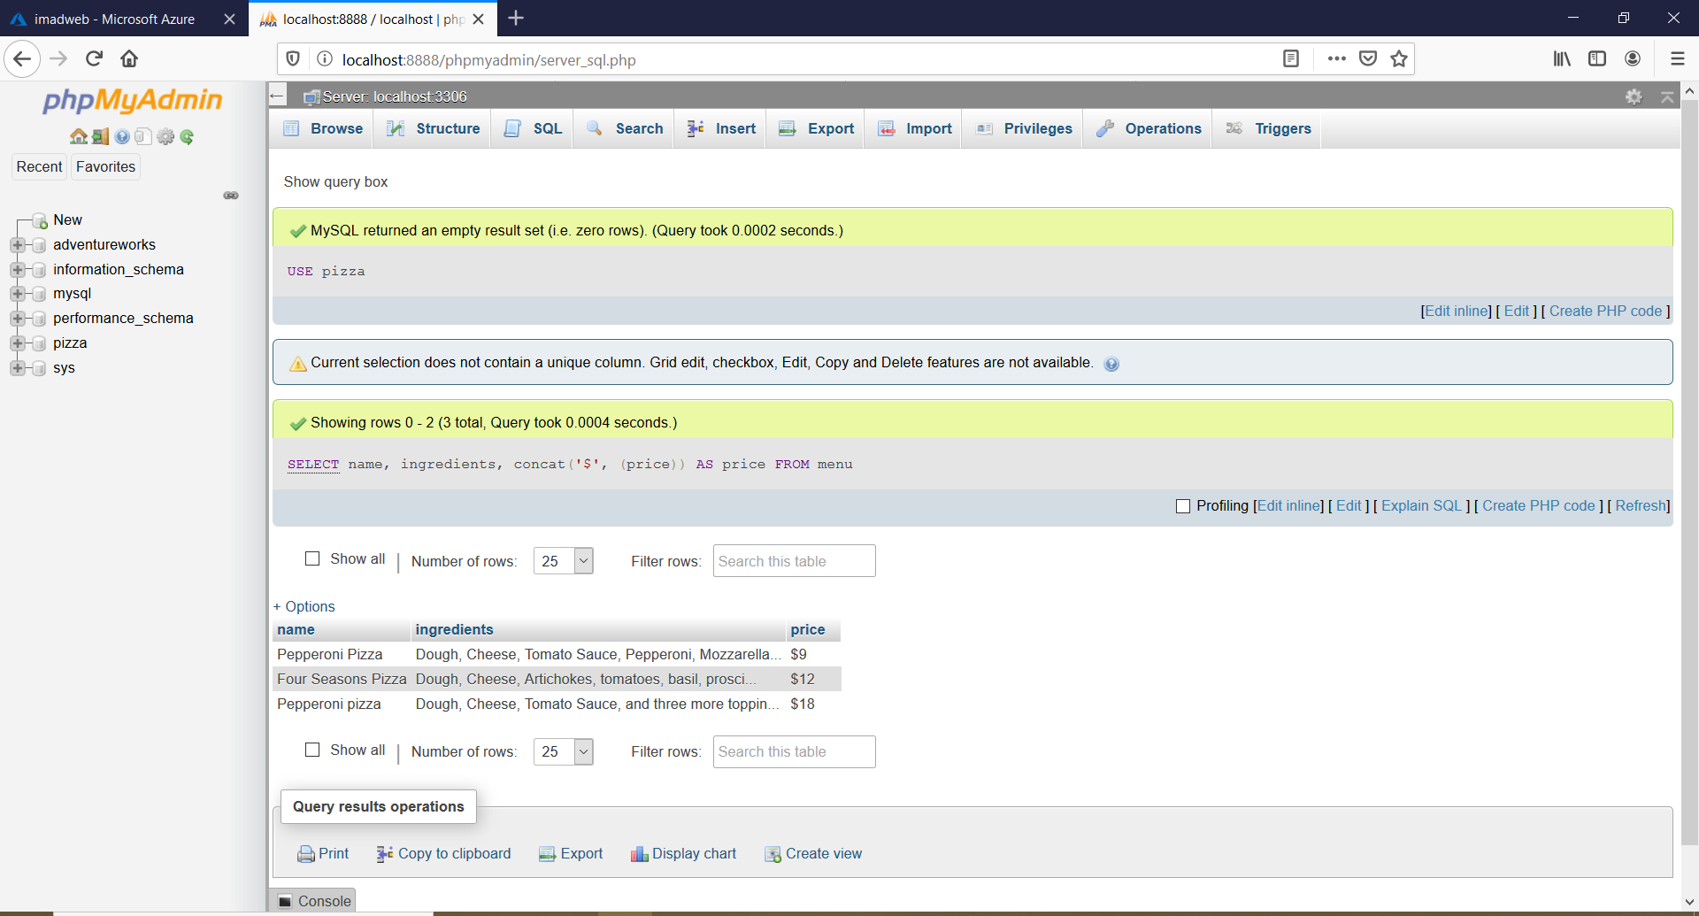

**Desktop view for the website**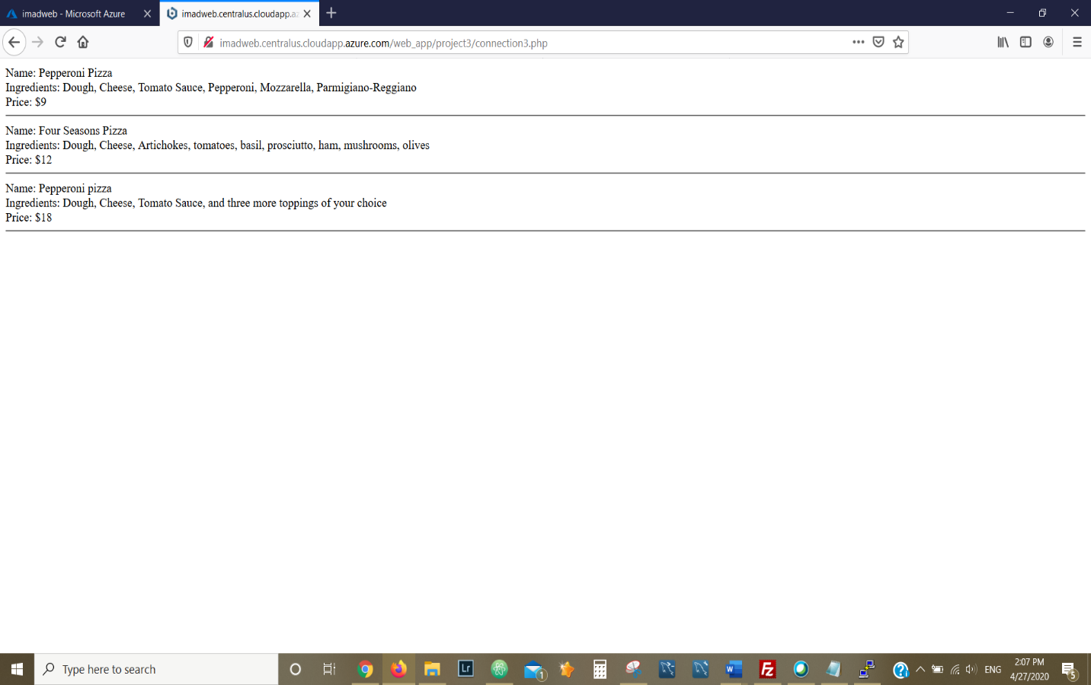

**Mobile view for the website**